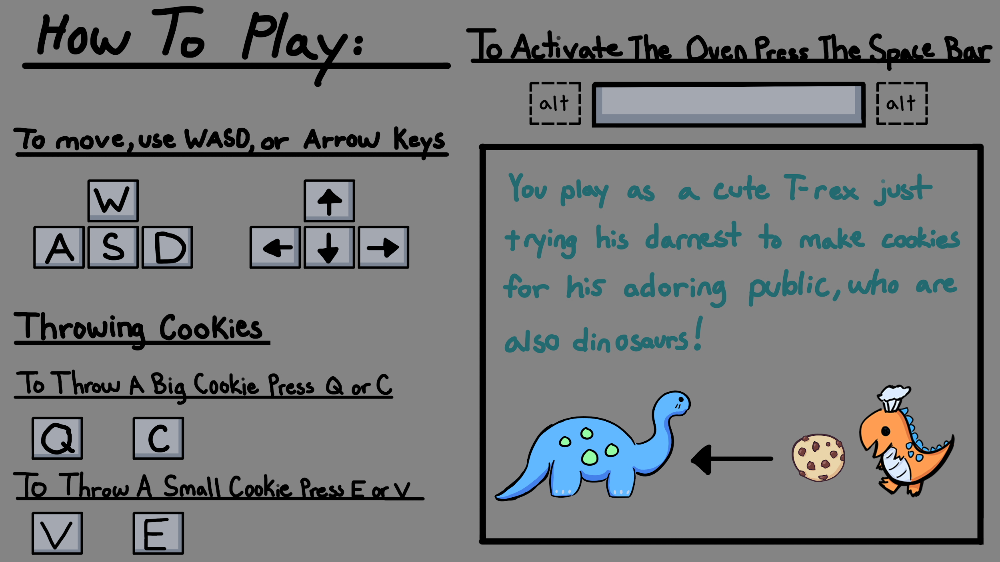

Installation

* You do not need to install the game; it is installed at <https://deusathemis.itch.io/dino-diner>

Credits

* Art
  + Tommy Xiong
  + Brandon Scott
* Programming
  + Kira Themis
  + Nathan Muck
* Made in 2020